TRIGGER

CREATE TABLE Employee (
Emp_ID INT PRIMARY KEY,
Emp_Name VARCHAR(100),
Salary DECIMAL(10, 2)
);
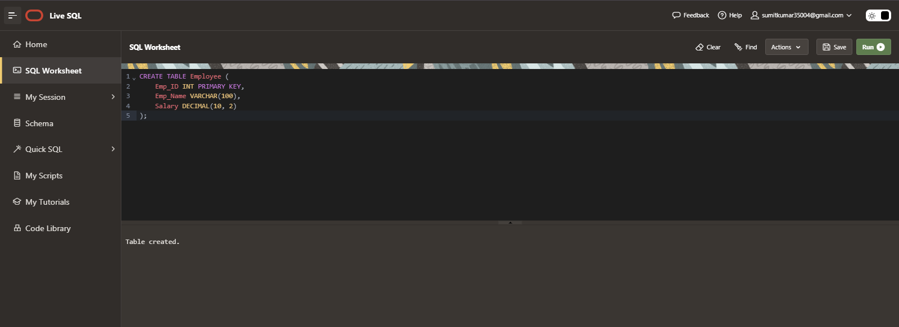
CREATE OR REPLACE TRIGGER trg_before_insert
BEFORE INSERT ON Employee
FOR EACH ROW
BEGIN
IF:NEW.salary IS NULL THEN
:NEW.salary:=30000;
END IF;
END;
/
CREATE OR REPLACE TRIGGER trg_before_insert
BEFORE INSERT ON Employee
FOR EACH ROW
BEGIN
IF:NEW.salary IS NULL THEN
:NEW.salary:=30000;
END IF;
END;
/
INSERT INTO Employee VALUES(35 , 'smith johnson' , NULL);
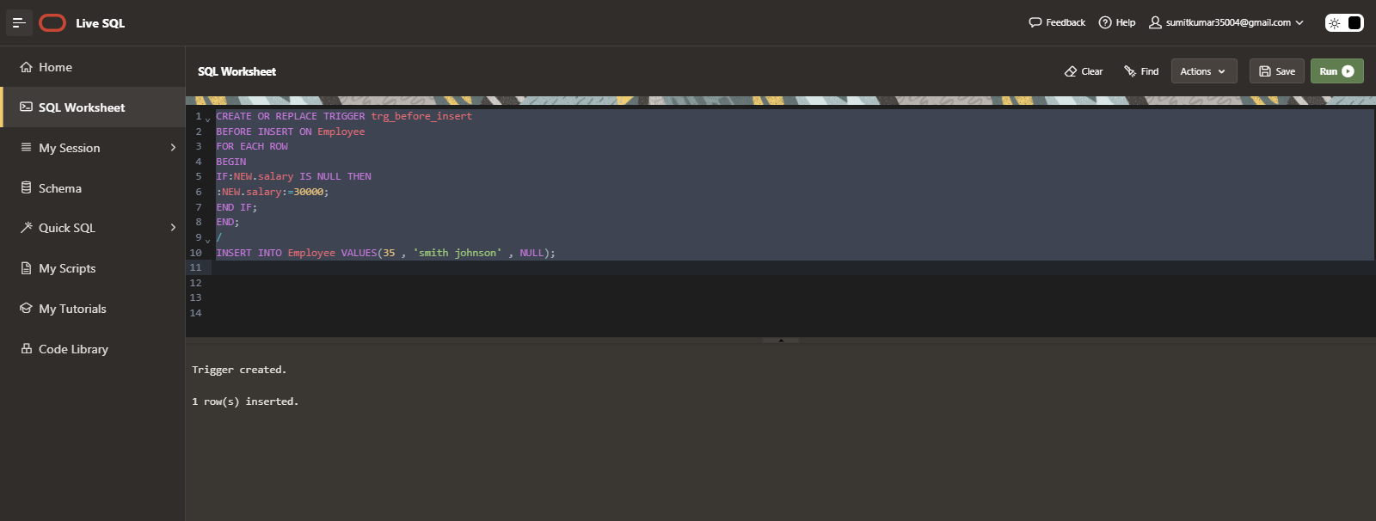
Select * From Employee
